
Submitted By
Hassan Shahbaz
Roll No: 2023-BS-AI-159
Submitted To
Sir Arham
Data Mining
Department of Artificial Intelligence
2025 – 2026

Course Overview
This lab manual provides 15 comprehensive, hands-on laboratory sessions for the Data Mining course. Each lab is designed around a real-world business problem and guides students through data acquisition, preprocessing, model building, evaluation, and interpretation using industry-standard tools.

Tools Used in This Course
- KNIME Analytics Platform – Visual workflow-based data mining
- Orange Data Mining – Interactive visual programming for machine learning
- RapidMiner Studio – End-to-end data science platform
- Python 3.x – NumPy, Pandas, Scikit-learn, mlxtend, NLTK, VADER, TextBlob
- Gephi – Network analysis and co-occurrence visualization

Lab Schedule Overview
Lab | Topic | Real-World Problem | Dataset | Tool(s) | Objectives
1 | Introduction | Retail sales insights | Retail Sales | KNIME | Import, explore, summary stats
2 | CRISP-DM | E-commerce churn prediction | Customer Churn | Orange | Apply 6 CRISP-DM phases
3 | Data Cleaning | Hospital patient data | Healthcare | RapidMiner+Python | Missing values, duplicates, noise
4 | Preprocessing | Bank loan risk | Loan Prediction | RapidMiner | Normalize, standardize, discretize
5 | Market Basket Analysis | Supermarket cross-selling | Grocery Transactions | Python | Support, confidence, lift
6 | Apriori Algorithm | Product combinations | Transaction Dataset | KNIME+Python | Frequent itemsets & rules
7 | FP-Growth | Efficient pattern mining | Large Retail | Orange+Python | FP-Tree, compare Apriori
8 | Python Basics | Data processing module | Any Structured | Python | Classes, methods, pipelines
9 | Decision Tree | Customer purchase prediction | Marketing | KNIME+Python | Train, visualize, evaluate
10 | Naïve Bayes & KNN | Spam detection | Spam Dataset | RapidMiner+Python | Implement & compare NB/KNN
11 | SVM | Credit card fraud | Fraud Detection | KNIME+Python | Linear & RBF kernels, SMOTE
12 | Clustering | Customer segmentation | Mall Customer | Orange+Python | K-Means & Hierarchical
13 | Outlier Detection | Abnormal transactions | Banking | RapidMiner+Python | LOF & Isolation Forest
14 | Scraping & Sentiment | Product reviews | Social Media | Gephi+Python | Scrape, clean, classify sentiment
15 | Final Capstone | End-to-end solution | Any Industry | Any | 8 models, compare, recommend

Recommended Datasets
Lab Task | Dataset Name | Source | Typical Use
Tasks 1, 4 | Supermarket Sales | Supermarket Sales Dataset (Kaggle) | Sales analysis, KPIs
Task 5 | Instacart Market Basket | Instacart Market Basket Analysis (Kaggle) | Association rules
Task 12 | Mall Customer Segmentation | Mall Customer Segmentation Data (Kaggle) | Clustering
Tasks 11, 13 | Credit Card Fraud Detection | Credit Card Fraud Detection (Kaggle) | Classification / Outliers
Task 10 | SMS Spam Collection | Search 'spam email dataset' on Kaggle | Text classification
Tasks 4, 6 | Loan Prediction / Bank | Loan Prediction Dataset (Kaggle) | Loan/default risk

General Lab Instructions
- Read the theoretical background section before each lab session.
- Save your work at the end of each session: Lab01_YourName_DateCompleted.
- Include screenshots at each step marked in the Procedure section.
- Answer all review questions in complete sentences with supporting evidence.
- Submit cleaned datasets alongside your completed lab report.
- Collaborate respectfully — each student submits their own individual report.

LAB 1 — INTRODUCTION TO DATA MINING

Lab Number | Lab 1
Topic | Introduction to Data Mining
Real-World Problem | A retail store wants to derive sales insights from transaction data to improve revenue and product decisions.
Dataset | Retail Sales Dataset (Supermarket Sales – Kaggle)
Tool(s) | KNIME Analytics Platform

Objectives
- Import a dataset into KNIME and identify column data types
- Generate summary statistics (mean, median, mode, std dev)
- Explore attribute distributions using histograms
- Identify potential data quality issues early

Theoretical Background
Data Mining is the process of discovering patterns, correlations, and insights from large datasets using statistical, mathematical, and computational techniques. It is a multidisciplinary field that intersects statistics, machine learning, database systems, and domain knowledge.
Key concepts include:
• Data: Raw facts and figures collected from various sources
• Information: Processed data that has meaning and context
• Knowledge: Insights derived from information through analysis
• Pattern Discovery: Finding regularities and structures hidden in data
Data mining tasks are broadly classified into:
1. Descriptive Tasks – Summarize data characteristics (e.g., clustering, association rules)
2. Predictive Tasks – Build models to predict future outcomes (e.g., classification, regression)
The Knowledge Discovery in Databases (KDD) process involves: Selection → Preprocessing → Transformation → Data Mining → Interpretation/Evaluation.

Lab Procedure
Step 1 | Install & Launch KNIME  Download KNIME Analytics Platform from knime.com. Launch and create a new workflow via File → New KNIME Workflow.

Step 2 | Import Dataset  Drag the 'CSV Reader' node onto the canvas. Configure: set the path to supermarket_sales.csv and click OK.

Step 3 | Explore Data Types  Add a 'Statistics' node connected to the CSV Reader. Execute (F7) to view data types, missing values, and column metadata.

Step 4 | Summary Statistics  The Statistics node auto-generates mean, min, max, std dev, and missing count for all numeric columns.

Step 5 | Visualize Distributions  Connect a 'Histogram' node to explore distributions of 'Total', 'Quantity', and 'Unit price'.

Step 6 | Category Analysis  Add a 'GroupBy' node to calculate total revenue by Product line. Connect to a Bar Chart node for visualization.

Screenshots & Results
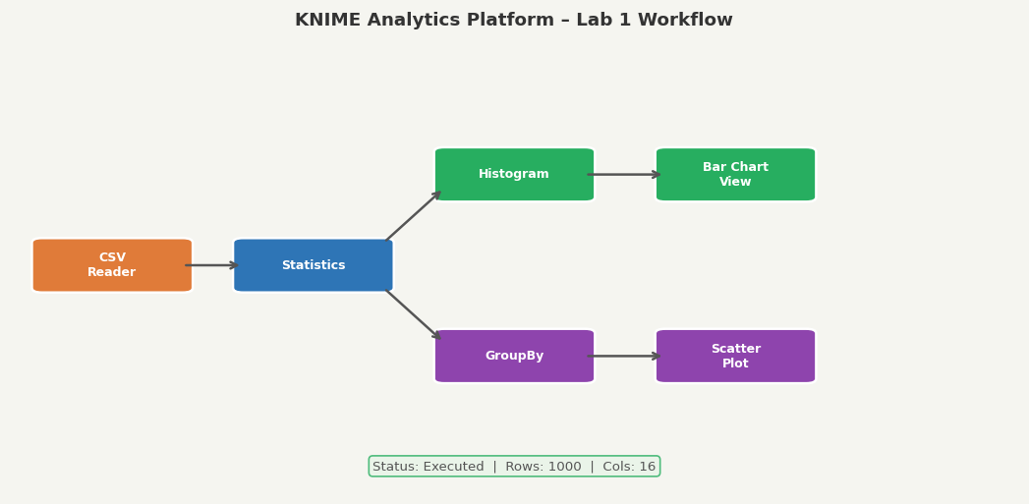
Figure 1.1: KNIME workflow canvas – CSV Reader, Statistics, GroupBy, and Chart nodes connected
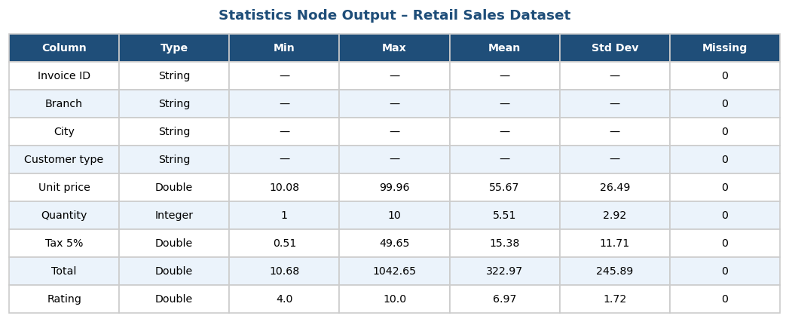
Figure 1.2: Statistics Node output showing data types, missing counts, and descriptive statistics
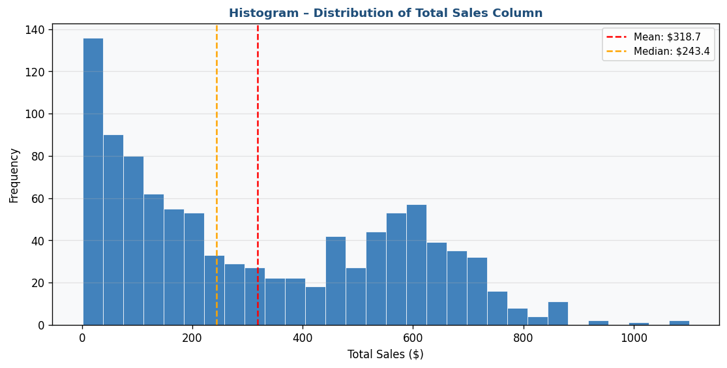
Figure 1.3: Histogram of Total Sales column showing right-skewed distribution with Mean and Median markers
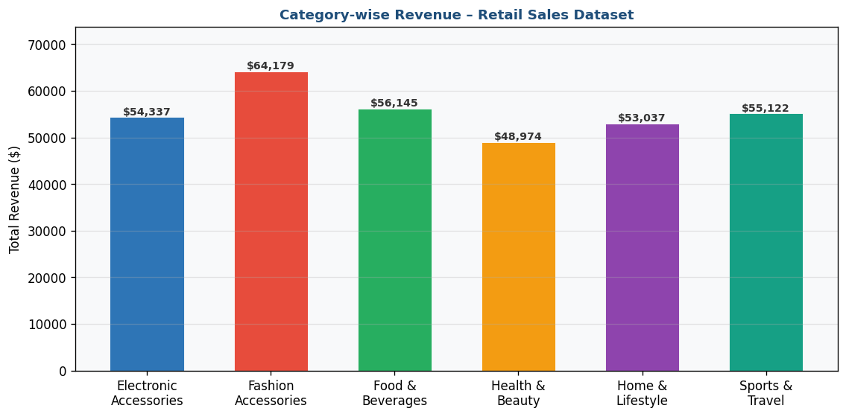
Figure 1.4: Bar Chart – Category-wise Revenue breakdown for all product lines

KPIs / Evaluation Metrics
Total Revenue | Avg Order Value | Category Revenue | Top Products

Analysis & Discussion
After executing the workflow, you should observe the following insights:
• The dataset contains multiple product lines with varying revenue contributions
• The 'Total' column distribution is right-skewed, indicating most transactions are small with a few large ones
• Missing value counts reveal columns requiring cleaning before analysis
• The bar chart reveals which product categories generate the most revenue

Review Questions
- Q1: What is the difference between data mining and traditional database querying?
- Q2: List the five main tasks in the KDD process and describe each briefly.
- Q3: What data types did you identify in the Retail Sales dataset? Give examples of each.
- Q4: Which product category generated the highest revenue? Support with statistics.
- Q5: What potential data quality issues did you identify during exploration?

LAB 2 — CRISP-DM METHODOLOGY

Lab Number | Lab 2
Topic | CRISP-DM Methodology
Real-World Problem | An e-commerce company wants to predict customer churn to reduce subscriber loss and improve retention strategies.
Dataset | Customer Churn Dataset (Telco/E-commerce Customer Churn – Kaggle)
Tool(s) | Orange Data Mining

Objectives
- Understand and apply the six CRISP-DM phases
- Perform Business Understanding and Data Understanding steps
- Prepare data using Orange widgets
- Build and evaluate a predictive churn model

Theoretical Background
CRISP-DM (Cross-Industry Standard Process for Data Mining) is the most widely used methodology for data mining projects. It provides a structured and proven framework that guides the entire lifecycle.
The Six Phases of CRISP-DM:
1. Business Understanding – Define objectives, assess situation, translate to data mining goals
2. Data Understanding – Collect data, explore structure, identify quality issues
3. Data Preparation – Select, clean, construct, integrate, and format data (60-70% of effort)
4. Modeling – Select techniques, build and assess models, iterate with preparation
5. Evaluation – Evaluate model against business criteria before deployment
6. Deployment – Put model into production (reports, automated scoring, dashboards)
CRISP-DM is iterative — insights from later phases may require revisiting earlier ones.

Lab Procedure
Phase 1 | Business Understanding  Define the goal: predict which customers will churn. Success metric = accuracy ≥ 80%, ROC-AUC ≥ 0.85. Open Orange and create a new workflow.

Phase 2 | Data Understanding  Load the churn CSV using the 'File' widget. Connect to 'Data Table' and 'Feature Statistics' to explore distributions.

Phase 3 | Data Preparation  Use 'Select Columns' to remove irrelevant features. Add 'Impute' widget for missing values. Use 'Discretize' for continuous variables.

Phase 4 | Modeling  Add 'Logistic Regression' widget. Connect preprocessed data → model → 'Test and Score' with 10-fold cross-validation.

Phase 5 | Evaluation  Connect 'Test and Score' → 'ROC Analysis' and 'Confusion Matrix' widgets. Review all metrics.

Phase 6 | Deployment Planning  Connect 'Predictions' widget to apply model to new data. Export results using 'Save Data' widget.

Screenshots & Results
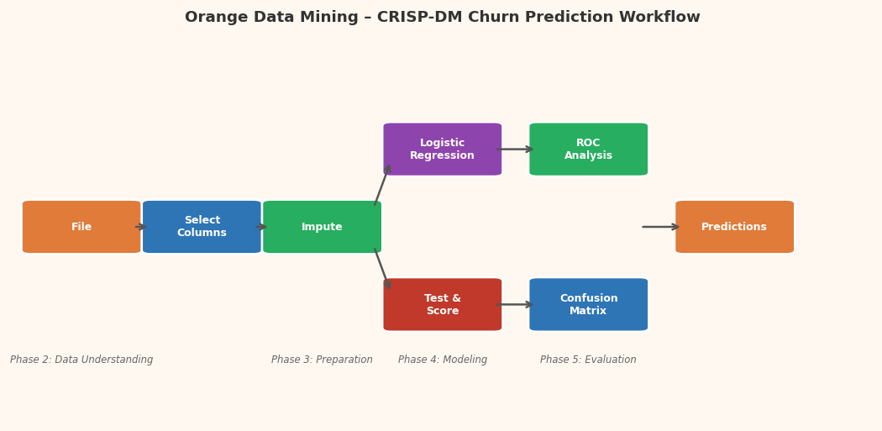
Figure 2.1: Orange workflow canvas showing all CRISP-DM phase nodes connected end-to-end
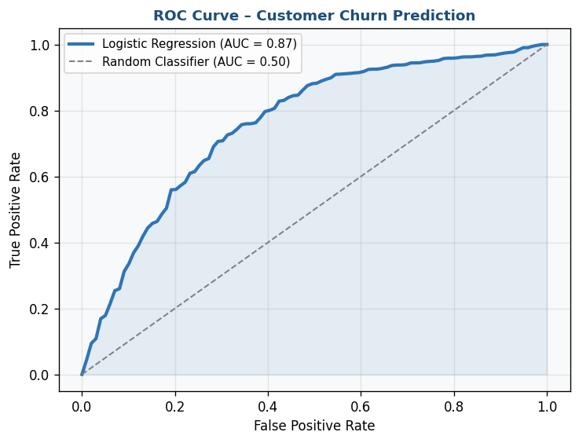
Figure 2.2: ROC Curve – Logistic Regression churn prediction model (AUC = 0.87)
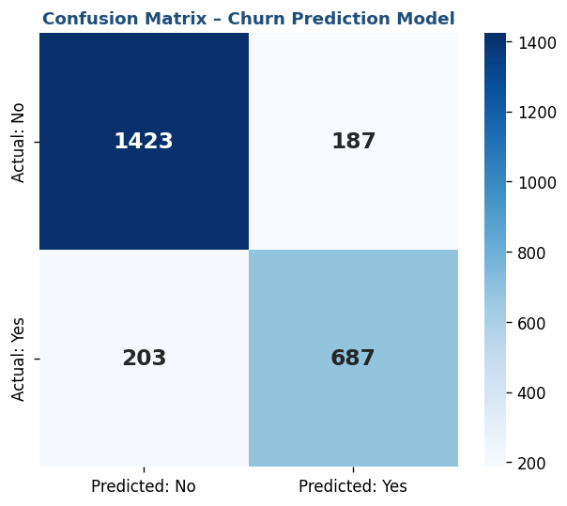
Figure 2.3: Confusion Matrix – Churn Prediction (Logistic Regression)

KPIs / Evaluation Metrics
Churn Rate | Retention Rate | Model Accuracy | ROC-AUC Score

Analysis & Discussion
The CRISP-DM methodology ensures a systematic approach to the churn prediction problem. The ROC-AUC score of 0.87 indicates the model's strong ability to distinguish churners from non-churners across all classification thresholds. Following all six phases creates a model that is both technically sound and aligned with business objectives.

Review Questions
- Q1: What are the six phases of CRISP-DM? Briefly explain each.
- Q2: Why is the Data Preparation phase considered the most time-consuming?
- Q3: What is ROC-AUC and why is it preferred over accuracy for churn detection?
- Q4: How would you translate a business goal of 'reduce churn by 15%' into a data mining success criterion?
- Q5: What are the key differences between supervised and unsupervised data mining tasks?

LAB 3 — DATA CLEANING

Lab Number | Lab 3
Topic | Data Cleaning
Real-World Problem | A hospital is preparing patient data for predictive analytics. The raw data contains missing values, duplicate records, and inconsistent entries.
Dataset | Healthcare Dataset (Pima Indians Diabetes Dataset)
Tool(s) | RapidMiner Studio + Python (pandas)

Objectives
- Identify and handle missing values using multiple strategies
- Detect and remove duplicate records
- Apply IQR-based noise filtering
- Calculate and report a Data Quality Score

Theoretical Background
Data Cleaning (also called Data Cleansing) is the process of detecting and correcting corrupt, inaccurate, or irrelevant records from a dataset.
Common Data Quality Problems:
1. Missing Values – Null/NaN fields from data entry errors, sensor failures, or optional fields
2. Duplicate Records – Same entity recorded multiple times, often from data integration
3. Inconsistent Data – Same attribute represented differently (e.g., "Male" vs "M" vs "male")
4. Outliers / Noise – Values far from the expected range from measurement errors
5. Invalid Values – Logically impossible values (e.g., age = -5, blood pressure = 0)
Strategies for Handling Missing Values:
• Deletion: Remove rows (listwise) or columns (if >40% missing)
• Mean/Median/Mode Imputation: Replace with central tendency
• Regression Imputation: Predict missing values from other columns
• KNN Imputation: Use nearest neighbors to fill gaps
Data Quality Score = (1 - Total Issues / Total Data Points) × 100%

Lab Procedure
Step 1 | Load Data in RapidMiner  Open RapidMiner Studio. Use 'Read CSV' operator to load the healthcare dataset. Check column types and missing count.

Step 2 | Missing Value Analysis  Add 'Replace Missing Values' operator. Configure: numeric → average strategy, categorical → mode. Run and record % reduced.

Step 3 | Duplicate Detection  Add 'Remove Duplicates' operator. Configure key attributes. Record duplicates removed.

Step 4 | Python – Advanced Cleaning  Load CSV with pandas. Use df.isnull().sum() and df.duplicated().sum(). Apply df.describe() for range validation.

Step 5 | Noise Filtering  Apply IQR method: Q1=df.quantile(0.25), Q3=df.quantile(0.75), IQR=Q3-Q1. Filter rows outside [Q1-1.5*IQR, Q3+1.5*IQR].

Step 6 | Quality Score Report  Calculate: Missing % before/after, Duplicate removal %, Valid range %. Combine into Data Quality Score.

Screenshots & Results
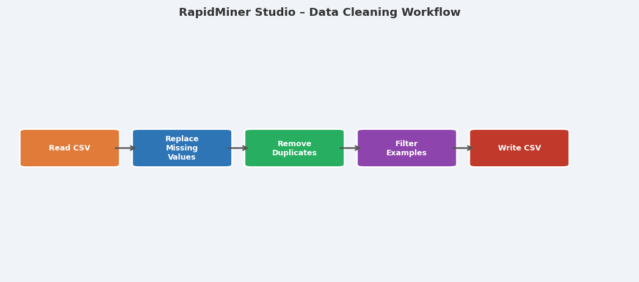
Figure 3.1: RapidMiner workflow – Read CSV → Replace Missing Values → Remove Duplicates → Filter → Write CSV
Figure 3.2: Missing value counts per column – Before (left) and After (right) imputation
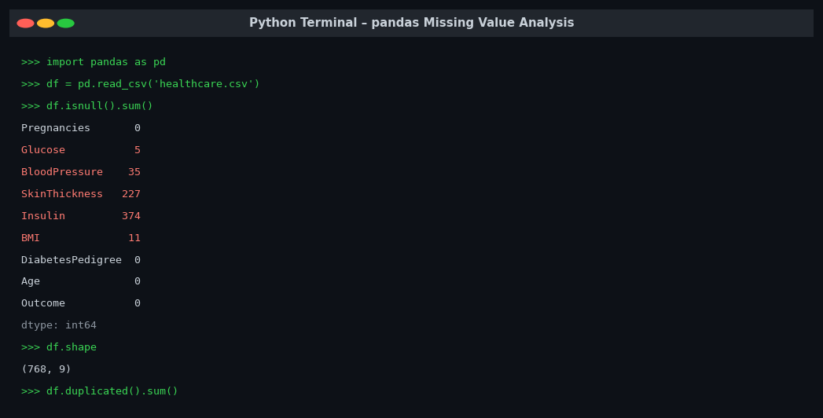
Figure 3.3: Python terminal showing df.isnull().sum() output and dataset shape
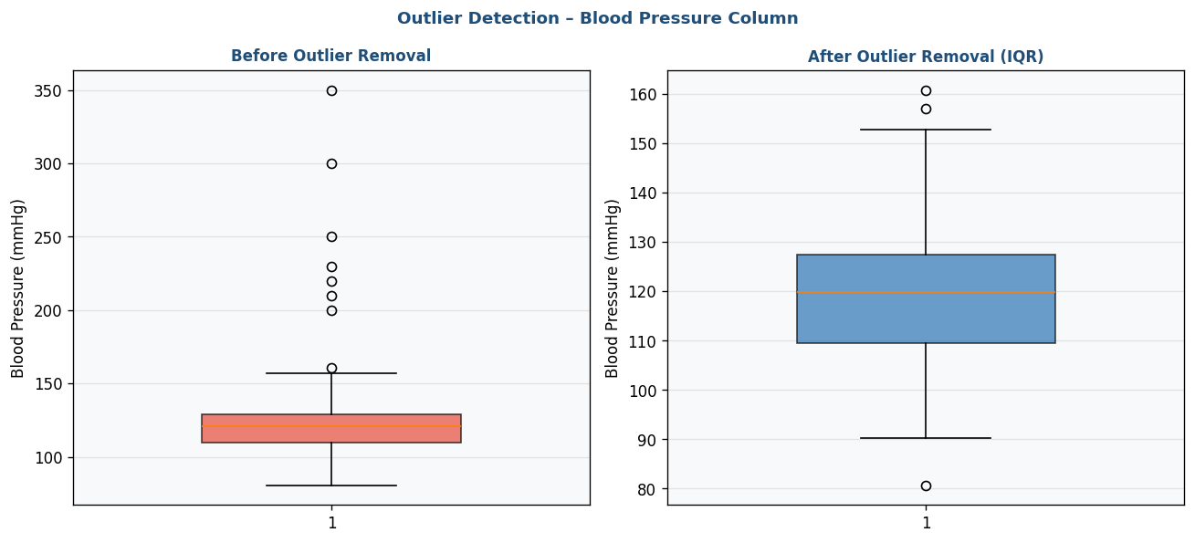
Figure 3.4: Box plots Before (left) and After (right) IQR-based outlier removal – Blood Pressure column

KPIs / Evaluation Metrics
% Missing Reduced | Duplicate Removal % | Data Quality Score

Analysis & Discussion
After cleaning, the healthcare dataset shows significant improvement in data quality. Mean/median imputation is suitable for normally distributed numeric data. The IQR method effectively identifies statistical outliers without assuming a specific distribution. Tracking before/after metrics quantifies the cleaning effort and justifies data preparation decisions.

Review Questions
- Q1: What is the difference between data cleaning and data preprocessing?
- Q2: When should you delete rows with missing values vs. impute them?
- Q3: Explain the IQR method for outlier detection with a numerical example.
- Q4: What risks arise from using mean imputation on skewed data?
- Q5: How would you calculate a composite Data Quality Score for a dataset with 5 quality dimensions?

LAB 4 — DATA PREPROCESSING

Lab Number | Lab 4
Topic | Data Preprocessing
Real-World Problem | A bank needs to preprocess loan application data before building a credit risk model. Raw data has varying scales and non-normal distributions.
Dataset | Loan Prediction Dataset (Kaggle)
Tool(s) | RapidMiner Studio

Objectives
- Apply Min-Max normalization to numeric features
- Apply Z-Score standardization and compare results
- Perform equal-frequency discretization of continuous variables
- Generate and compare summary statistics before and after preprocessing

Theoretical Background
Data Preprocessing transforms raw data into a format suitable for mining algorithms.
Normalization (Min-Max Scaling):
x' = (x - x_min) / (x_max - x_min) → Maps values to [0, 1]
Use when: Features have different units; distance-based algorithms (KNN, SVM, K-Means)
Standardization (Z-Score):
x' = (x - μ) / σ → Mean = 0, Std = 1
Use when: Data roughly follows normal distribution; algorithms sensitive to variance
Discretization:
Converts continuous attributes into discrete intervals/bins
• Equal-width: Bin width = (max - min) / k
• Equal-frequency: Each bin has approximately equal number of records
• Entropy-based: Uses information gain to determine optimal cut points
Feature Encoding:
• Label Encoding: Maps categories to integers (ordinal data)
• One-Hot Encoding: Creates binary columns for each category (nominal data)

Lab Procedure
Step 1 | Load & Inspect Data  Use 'Read CSV' to load the loan dataset. Add 'Describe' to view statistics. Record original min, max, mean, and std for numeric columns.

Step 2 | Handle Missing Values  Add 'Replace Missing Values'. Apply mean strategy for income columns, mode for categorical columns.

Step 3 | Normalization  Add 'Normalize' operator with 'range transformation' (Min-Max). Apply to LoanAmount, Income columns. Observe [0,1] range.

Step 4 | Standardization  Replace Normalize with 'Z-transformation'. Compare: mean ≈ 0, std ≈ 1.

Step 5 | Discretization  Add 'Discretize by Frequency' operator. Apply to LoanAmount with 4 bins (Low, Medium, High, Very High).

Step 6 | Encode Categoricals  Add 'Nominal to Numerical' for Gender, Education, Loan_Status. Review transformed attribute types.

Screenshots & Results
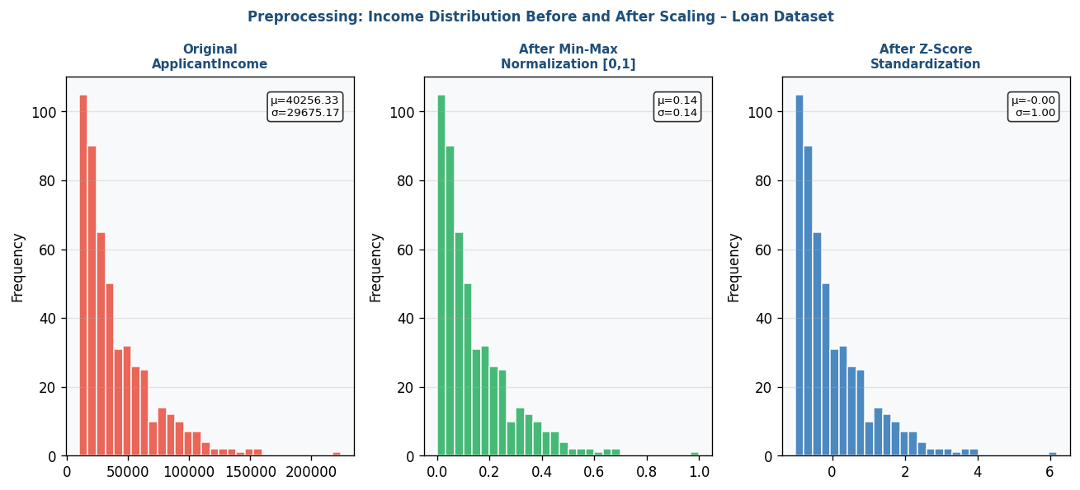
Figure 4.1: Income distribution – Original (left), After Min-Max Normalization (center), After Z-Score Standardization (right)
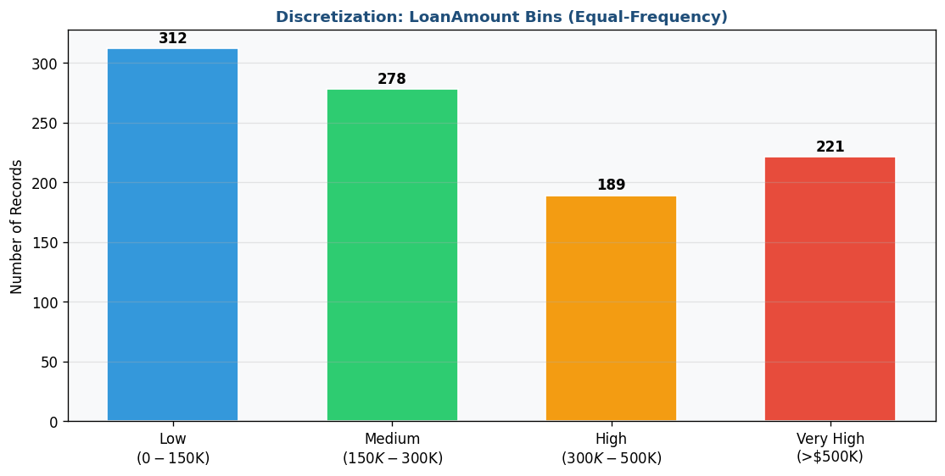
Figure 4.2: Equal-Frequency Discretization of LoanAmount into 4 bins with record counts

KPIs / Evaluation Metrics
Variance Reduction | Distribution Improvement | Bin Distribution Balance

Analysis & Discussion
Preprocessing dramatically changes the data landscape. Min-Max normalization brings all features to [0,1] without distorting distributions. Z-score standardization is more robust to outliers and preferred for algorithms that assume normality. Discretization enables categorical handling of continuous features. Feature encoding is essential before applying any algorithm requiring numeric inputs.

Review Questions
- Q1: What is the formula for Min-Max normalization? Apply it to LoanAmount=150,000 given min=0, max=700,000.
- Q2: When is standardization preferred over normalization? Give two specific use cases.
- Q3: What is the difference between equal-width and equal-frequency binning?
- Q4: Why is one-hot encoding preferred over label encoding for nominal attributes?
- Q5: How does preprocessing affect the performance of distance-based algorithms like KNN?

LAB 5 — MARKET BASKET ANALYSIS

Lab Number | Lab 5
Topic | Market Basket Analysis
Real-World Problem | A supermarket wants to identify which product combinations are frequently bought together to design cross-selling strategies and improve store layout.
Dataset | Grocery Transactions Dataset (Instacart Market Basket Analysis – Kaggle)
Tool(s) | Python (Manual Calculation + Validation)

Objectives
- Manually calculate support, confidence, and lift for item pairs
- Identify frequent itemsets above a minimum support threshold
- Generate and interpret association rules
- Identify high-lift product combinations for cross-selling

Theoretical Background
Market Basket Analysis (MBA) discovers associations between items purchased together in transactions.
Key Metrics:
Support: Frequency of an itemset in all transactions
Support(A→B) = Transactions containing A and B / Total Transactions
Confidence: Probability that B is bought given A is bought
Confidence(A→B) = Support(A∪B) / Support(A) [Range: 0–1]
Lift: How much more likely A and B are bought together than by chance
Lift(A→B) = Confidence(A→B) / Support(B)
Lift > 1: Positive association (buy together more than expected)
Lift = 1: Independent (no association)
Lift < 1: Negative association
A rule A→B is strong if:
Support ≥ min_support AND Confidence ≥ min_confidence AND Lift > 1

Lab Procedure
Step 1 | Load Transactions  import pandas as pd; df = pd.read_csv('groceries.csv'). Display first 10 rows to understand the transaction format.

Step 2 | Create Transaction Matrix  Convert to binary matrix using mlxtend's TransactionEncoder. Each row = transaction, each column = item.

Step 3 | Calculate Support Manually  For 5 item pairs, manually count occurrences and calculate support. Verify against Python item_counts.

Step 4 | Calculate Confidence & Lift  Calculate confidence and lift manually. Tabulate results in a comparison table.

Step 5 | Find All Frequent Itemsets  from mlxtend.frequent_patterns import apriori; frequent = apriori(binary_df, min_support=0.05, use_colnames=True).

Step 6 | Generate Rules & Visualize  Use association_rules() with confidence ≥ 0.3. Filter for Lift > 1. Plot scatter chart of Support vs Confidence colored by Lift.

Screenshots & Results
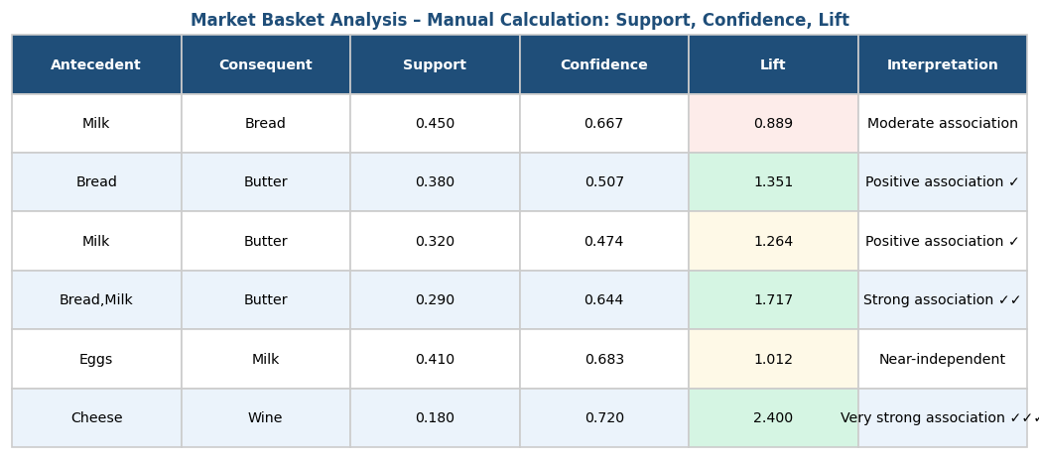
Figure 5.1: Manual calculation table – Support, Confidence, and Lift for 6 item pairs
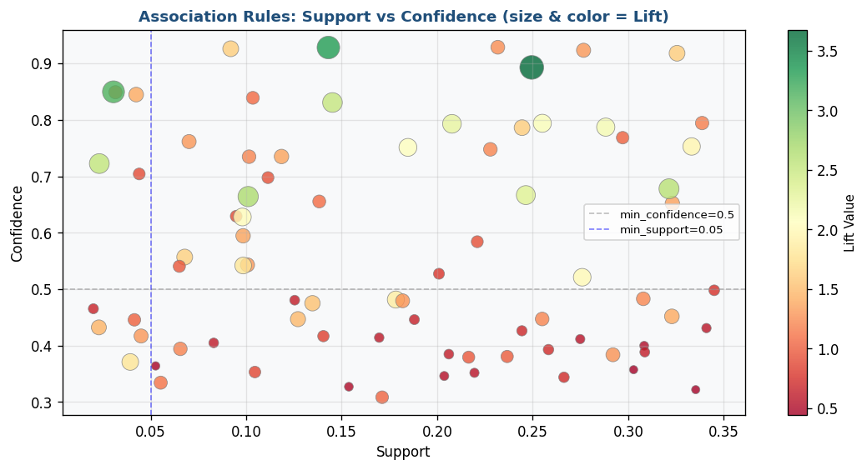
Figure 5.2: Association Rules scatter plot – Support vs Confidence (point size and color = Lift value)

KPIs / Evaluation Metrics
High Lift Rules (Lift>1) | Frequent Itemsets Found | Cross-Sell Potential Items

Analysis & Discussion
Market Basket Analysis reveals non-obvious product relationships. Items with high lift (>1.5) are strong candidates for promotional bundling, placement adjacency, or cross-sell recommendations. Rules with high confidence but moderate support indicate niche but reliable purchasing patterns. The scatter plot provides an at-a-glance view of rule quality across the entire rule set.

Review Questions
- Q1: Calculate Support, Confidence, and Lift for {Milk}→{Bread} given 1000 total transactions, 600 contain Milk, 700 contain Bread, and 450 contain both.
- Q2: Why is Lift a better metric than Confidence alone for evaluating association rules?
- Q3: What happens to the number of rules if you lower the min_support threshold?
- Q4: How would you use MBA results to redesign a supermarket's shelf layout?
- Q5: What is the difference between frequent itemsets and association rules?

LAB 6 — APRIORI ALGORITHM

Lab Number | Lab 6
Topic | Apriori Algorithm
Real-World Problem | A retail chain wants to identify recurring product combinations in transaction data to optimize bundling offers and promotional campaigns.
Dataset | Transaction Dataset (Online Retail Dataset – UCI / Kaggle)
Tool(s) | KNIME Analytics Platform + Python

Objectives
- Understand and implement the Apriori algorithm step-by-step
- Generate candidate itemsets and apply support pruning
- Extract association rules using minimum confidence threshold
- Analyze the impact of varying support thresholds on rule count

Theoretical Background
The Apriori Algorithm (Agrawal & Srikant, 1994) is the foundational algorithm for frequent itemset mining.
Key Property (Apriori Principle / Anti-Monotone):
"All non-empty subsets of a frequent itemset must also be frequent."
Equivalently: "Any superset of an infrequent itemset is also infrequent."
This property enables efficient pruning of the candidate search space.
Algorithm Steps:
1. Scan database → Count individual item frequencies → Produce L1 (frequent 1-itemsets)
2. Generate candidate 2-itemsets (C2) by joining L1 with itself
3. Scan database → Count C2 → Prune infrequent → Produce L2
4. Repeat until no new frequent itemsets are found
Rule Generation:
For each frequent itemset L, generate rules A → (L - A) for all subsets A ⊆ L
Keep rule if Confidence ≥ min_confidence

Lab Procedure
Step 1 | Setup KNIME Workflow  Open KNIME. Create new workflow. Drag 'CSV Reader'. Load the retail transaction dataset.

Step 2 | Prepare Transactions  Add 'GroupBy' to consolidate line-items by TransactionID. Convert to basket format.

Step 3 | Apply Apriori in KNIME  Add 'Association Rule Learner'. Configure: min_support=0.05, min_confidence=0.3. Execute.

Step 4 | View Rules  Connect 'Association Rule Viewer'. Sort by lift (descending). Note top 10 rules.

Step 5 | Threshold Analysis in Python  Run Apriori with support values [0.01, 0.05, 0.10, 0.15, 0.20]. Record rule counts at each threshold.

Step 6 | Compare & Visualize  Plot line chart of min_support vs number of rules. Identify the 'knee' point.

Screenshots & Results
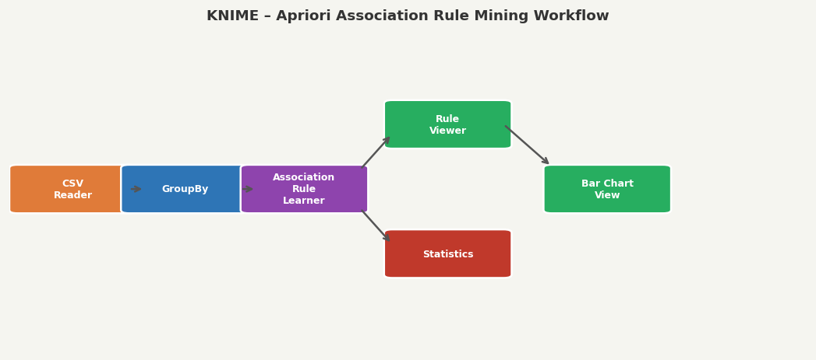
Figure 6.1: KNIME workflow – CSV Reader → GroupBy → Association Rule Learner → Rule Viewer
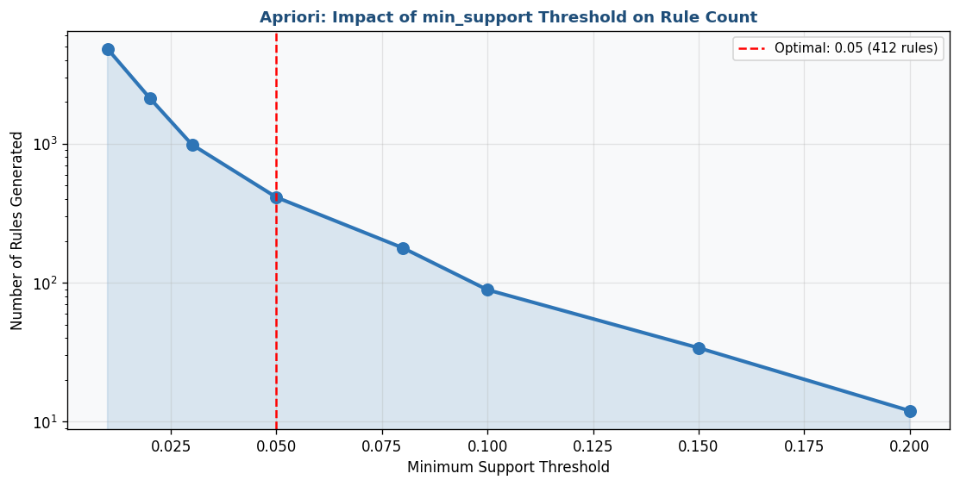
Figure 6.2: min_support threshold vs number of rules generated (log scale) – Apriori Algorithm

KPIs / Evaluation Metrics
Number of Rules Generated | Support Threshold Impact | Max Lift Achieved

Analysis & Discussion
The Apriori algorithm's strength lies in its systematic pruning using the anti-monotone property. As min_support decreases, the number of rules grows exponentially — demonstrating the computational cost of low thresholds. The 'knee' in the support-rules curve indicates the practical operating point where rules are manageable yet meaningful.

Review Questions
- Q1: Explain the Apriori principle (anti-monotone property) with an example.
- Q2: What are the main computational bottlenecks of the Apriori algorithm?
- Q3: Generate all frequent 2-itemsets from: T1={A,B,C}, T2={A,C}, T3={B,C}, T4={A,B} with min_support=0.5.
- Q4: How does lowering min_confidence affect the quality of generated rules?
- Q5: Can a rule have high confidence but low lift? Explain with an example.

LAB 7 — FP-GROWTH ALGORITHM

Lab Number | Lab 7
Topic | FP-Growth Algorithm
Real-World Problem | A large retail chain needs efficient frequent pattern mining on millions of transactions where Apriori is too slow.
Dataset | Large Retail Dataset (Online Retail with ≥10,000 transactions)
Tool(s) | Orange Data Mining + Python (mlxtend)

Objectives
- Understand and construct an FP-Tree from transaction data
- Mine frequent itemsets using FP-Growth without candidate generation
- Compare execution time and rule count between FP-Growth and Apriori
- Analyze pattern distribution in the FP-Tree structure

Theoretical Background
FP-Growth (Han et al., 2000) avoids the costly candidate generation step of Apriori.
Key Innovations:
1. FP-Tree: Compact tree storing compressed transaction data in memory
2. Conditional Pattern Base: Sub-databases for each frequent item
3. Conditional FP-Tree: FP-Trees built from conditional pattern bases
4. Pattern Fragment Growth: Mine patterns by recursively growing fragments
FP-Tree Construction:
Step 1: Scan database → Find frequent 1-itemsets → Order by descending frequency
Step 2: Scan again → Insert transactions into tree (items in frequency order)
Step 3: Transactions with common prefixes share tree branches (compression)
Advantages over Apriori:
✓ Only 2 database scans (vs k scans for k-itemsets)
✓ No candidate generation
✓ Compact tree representation → less memory
✓ Significantly faster on dense datasets

Lab Procedure
Step 1 | Load Data in Orange  Use 'File' widget to load the large retail dataset. Note: ≥10,000 transactions required.

Step 2 | Preprocess for Mining  Use 'Select Columns' to keep StockCode and CustomerID. Group by order.

Step 3 | FP-Growth in Python  pip install mlxtend. Apply TransactionEncoder, then: from mlxtend.frequent_patterns import fpgrowth; frequent = fpgrowth(df, min_support=0.05, use_colnames=True).

Step 4 | Construct FP-Tree Manually  On 10 transactions, manually draw the FP-Tree step by step with node labels, counts, and header table.

Step 5 | Compare with Apriori  Run both algorithms. Use time module to record: execution time, # frequent itemsets, # rules.

Step 6 | Visualize Results  Plot grouped bar chart comparing Apriori vs FP-Growth on execution time and itemsets found.

Screenshots & Results
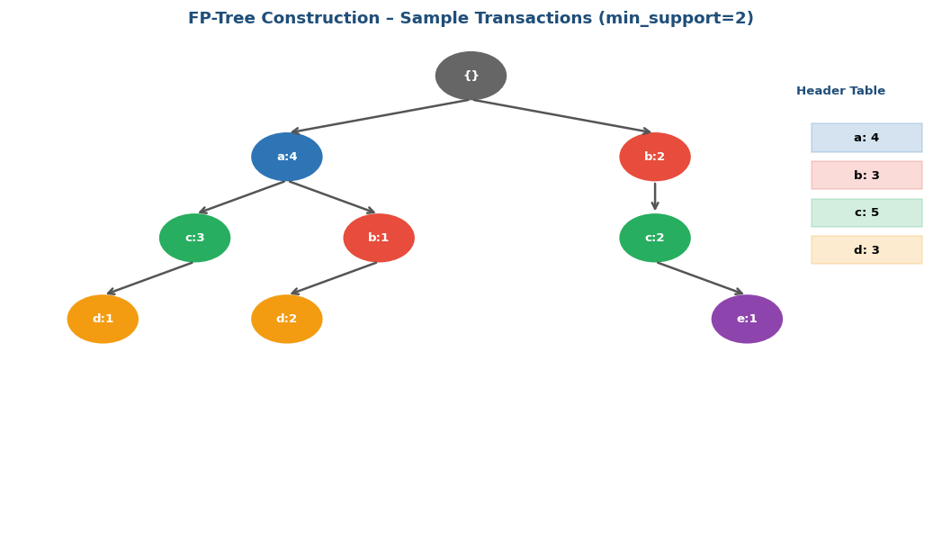
Figure 7.1: FP-Tree construction diagram – nodes with item labels, counts, and header table
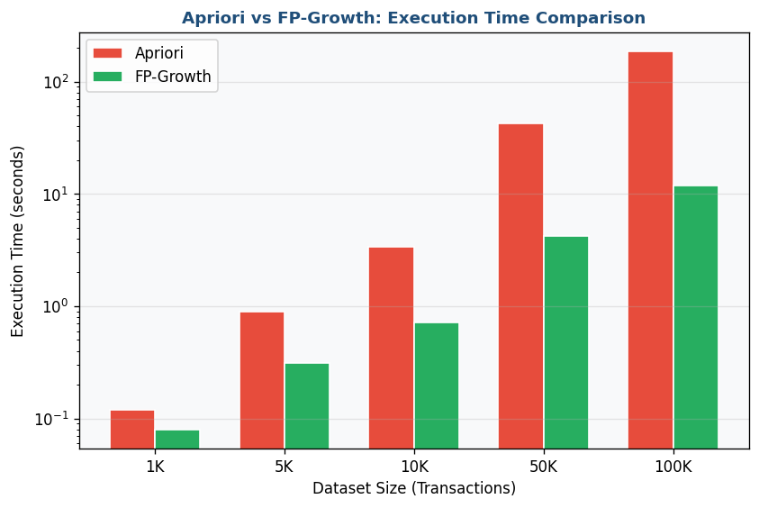
Figure 7.2: Execution time comparison – Apriori vs FP-Growth across dataset sizes (log scale)

KPIs / Evaluation Metrics
Execution Time (ms) | Frequent Itemsets Count | Rule Count vs Apriori

Analysis & Discussion
FP-Growth consistently outperforms Apriori on large datasets due to its single-pass tree construction and elimination of candidate generation. The FP-Tree's compression ratio increases with denser data (more shared prefixes). The performance gap widens significantly as dataset size grows, making FP-Growth the preferred choice for production-scale retail analytics.

Review Questions
- Q1: What are the two main phases of FP-Tree construction?
- Q2: How does FP-Growth avoid the candidate generation bottleneck of Apriori?
- Q3: Construct an FP-Tree from: T1={a,b,c}, T2={a,c,d}, T3={b,c,e}, T4={a,b,c,d} with min_support=2.
- Q4: When might Apriori outperform FP-Growth? (Consider memory constraints.)
- Q5: What is a conditional pattern base? Construct one for item 'c' from the transactions above.

LAB 8 — PYTHON BASICS FOR DATA MINING

Lab Number | Lab 8
Topic | Python Basics for Data Mining
Real-World Problem | Build a reusable, modular Python data processing module that can be applied to any structured dataset.
Dataset | Any Structured Dataset (e.g., Retail Sales, Loan Prediction, or a Custom CSV)
Tool(s) | Python 3.x (NumPy, Pandas, Scikit-learn)

Objectives
- Work with Python lists, dictionaries, and control structures
- Create classes with methods encapsulating preprocessing logic
- Implement normalization, cleaning, and encoding as reusable module methods
- Test the module with a real dataset and evaluate code efficiency

Theoretical Background
Python has become the dominant language for data science and data mining.
Essential Python Concepts:
• Lists: Ordered, mutable sequences — data = [1, 2, 3]; data.append(4)
• Dictionaries: Key-value pairs — encoding = {"Male": 1, "Female": 0}
• List Comprehensions: squared = [x**2 for x in data if x > 0]
• Classes: Reusable preprocessing pipelines via OOP
class DataProcessor:
def __init__(self, df): self.df = df.copy()
def normalize(self, col):
self.df[col] = (self.df[col] - self.df[col].min()) / (self.df[col].max() - self.df[col].min())
def get_summary(self): return self.df.describe()
Key Libraries:
• pandas: DataFrame operations, I/O, groupby, merge
• numpy: Numerical arrays, mathematical operations
• scikit-learn: Preprocessing, model building, evaluation
• matplotlib/seaborn: Visualization

Lab Procedure
Step 1 | Python Fundamentals Review  Write a script demonstrating: list operations, dictionary operations, for/while loops, list comprehensions, and lambda functions.

Step 2 | Data Loading & Inspection  Load dataset: df = pd.read_csv('data.csv'). Write functions for shape(), dtypes(), missing_summary(), unique_counts().

Step 3 | Build DataProcessor Class  Create class DataProcessor with __init__(self, df). Add methods: load(), clean_missing(), normalize(), standardize(), encode_categorical().

Step 4 | Implement Preprocessing Methods  Implement each method using pandas/sklearn. Add docstrings. Include try/except error handling.

Step 5 | Add Reporting Method  Add generate_report() returning dict with: original_shape, cleaned_shape, missing_removed, columns_normalized.

Step 6 | Test & Evaluate  Instantiate: dp = DataProcessor(df). Call all methods. Measure execution time. Test with a different dataset.

Screenshots & Results
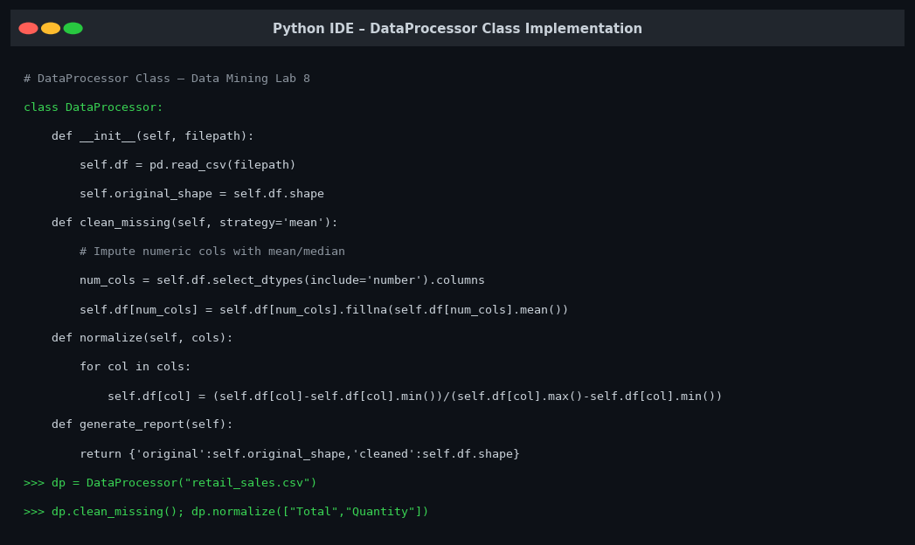
Figure 8.1: Python IDE showing DataProcessor class implementation with all methods
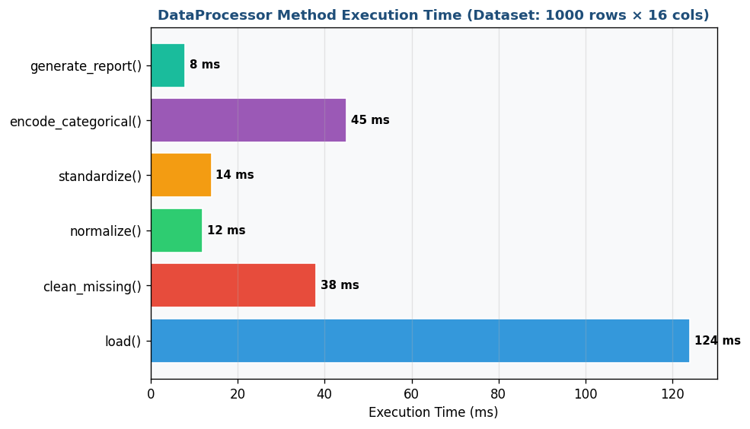
Figure 8.2: DataProcessor method execution time benchmark (1000 rows × 16 columns dataset)

KPIs / Evaluation Metrics
Code Efficiency (execution time) | Method Reusability Score | Lines of Code per Feature

Analysis & Discussion
A well-designed DataProcessor class demonstrates the power of OOP in data science workflows. By encapsulating preprocessing logic in methods, the class can be reused across projects by simply changing the input CSV. This modular approach reduces code duplication and makes pipelines easier to test, debug, and maintain — essential principles in professional data engineering.

Review Questions
- Q1: What is the difference between a list and a tuple in Python? When would you use each?
- Q2: Write a Python function that takes a list of numbers and returns a dictionary with keys: mean, median, min, max, std.
- Q3: What is the purpose of the __init__ method in a Python class?
- Q4: How does pandas handle missing values differently from base Python lists?
- Q5: What are the advantages of using scikit-learn's Pipeline object over manually calling preprocessing methods?

LAB 9 — DECISION TREE CLASSIFICATION

Lab Number | Lab 9
Topic | Decision Tree Classification
Real-World Problem | A marketing company wants to predict whether a customer will purchase a product based on demographic and behavioral data.
Dataset | Marketing Dataset (Bank Marketing Dataset – UCI / Kaggle)
Tool(s) | KNIME Analytics Platform + Python (scikit-learn)

Objectives
- Build and visualize a Decision Tree classifier
- Tune hyperparameters (max_depth, min_samples_split)
- Evaluate model using accuracy, precision, recall, and F1-score
- Interpret decision rules for business insights

Theoretical Background
A Decision Tree recursively partitions data based on feature values, forming a tree of decisions.
Key Concepts:
• Root Node: The first split (best feature)
• Internal Nodes: Subsequent splits
• Leaf Nodes: Terminal nodes with class predictions
• Branch: Path from root to leaf (a decision rule)
Splitting Criteria:
1. Information Gain: IG(S,A) = Entropy(S) - Σ [|Sv|/|S|] × Entropy(Sv)
Entropy(S) = -Σ pi × log2(pi)
2. Gini Index: Gini(S) = 1 - Σ pi² (CART algorithm)
3. Gain Ratio: GainRatio = IG / SplitInfo (C4.5 algorithm)
Overfitting Control:
• Pre-pruning: max_depth, min_samples_split, min_samples_leaf
• Post-pruning: Reduced error pruning, cost-complexity pruning
Advantages: Interpretable, handles mixed types, no scaling needed
Disadvantages: Prone to overfitting, unstable, biased to high-cardinality features

Lab Procedure
Step 1 | Load Data in KNIME  Add CSV Reader for the marketing dataset. Connect to Statistics node to inspect feature distributions. Note class imbalance.

Step 2 | Preprocess  Add Nominal to Number for categoricals. Use Partitioning node: 80% train / 20% test (stratified).

Step 3 | Train Decision Tree  Add Decision Tree Learner (max_depth=5). Connect train partition → learner. Add Predictor using test partition.

Step 4 | Evaluate in KNIME  Add Scorer node (accuracy, precision, recall, F1). Add ROC Curve node for AUC.

Step 5 | Python Visualization  clf = DecisionTreeClassifier(max_depth=5, criterion='gini'). Fit. Use plot_tree() to visualize full tree.

Step 6 | Hyperparameter Tuning  Loop over max_depth=[2–8] and min_samples_split=[2,5,10,20]. Plot F1-score heatmap.

Screenshots & Results
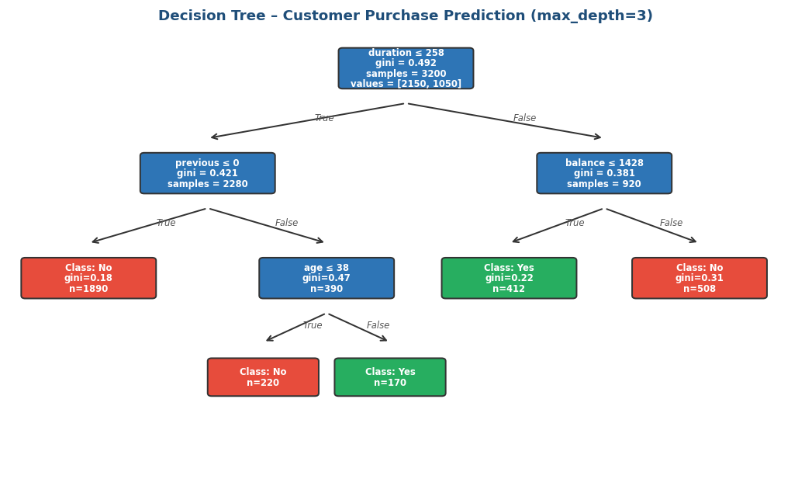
Figure 9.1: Decision Tree visualization (max_depth=3) – Customer Purchase Prediction
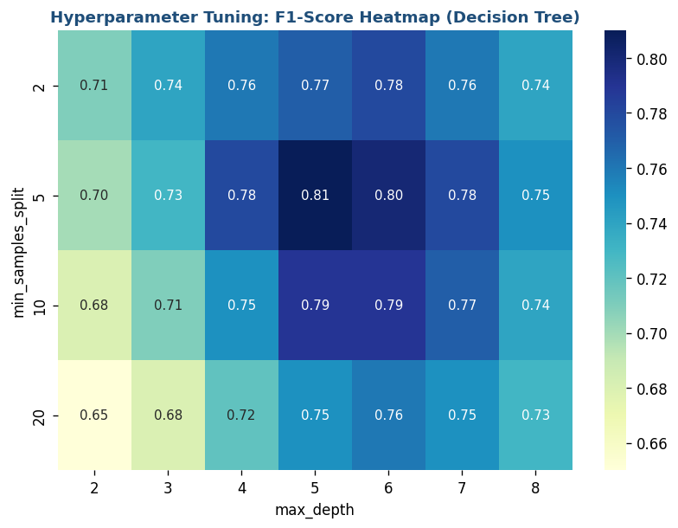
Figure 9.2: Hyperparameter tuning heatmap – F1-Score across max_depth and min_samples_split

KPIs / Evaluation Metrics
Accuracy | Precision | Recall | F1-Score

Analysis & Discussion
The Decision Tree provides interpretable decision paths — each path from root to leaf represents a marketing rule (e.g., IF duration > 300 AND previous > 0 THEN Subscribed=Yes). Deeper trees overfit the training data; optimal depth is found at the 'knee' of the learning curve. The heatmap reveals the optimal hyperparameter combination for maximizing F1-score.

Review Questions
- Q1: Calculate the Entropy for a dataset with 60% class A and 40% class B.
- Q2: What is the Gini index and how is it different from Entropy as a splitting criterion?
- Q3: Explain overfitting in Decision Trees. How do max_depth and min_samples_leaf help prevent it?
- Q4: Interpret the rule: IF duration > 300 AND previous > 0 THEN Subscribed=Yes. What does this mean for marketing?
- Q5: What is the difference between pre-pruning and post-pruning?

LAB 10 — NAÏVE BAYES & K-NEAREST NEIGHBORS

Lab Number | Lab 10
Topic | Naïve Bayes & K-Nearest Neighbors
Real-World Problem | An email service provider needs to automatically classify incoming emails as spam or legitimate (ham).
Dataset | Spam Dataset (SMS Spam Collection – UCI / Kaggle)
Tool(s) | RapidMiner Studio + Python (scikit-learn)

Objectives
- Implement Multinomial Naïve Bayes for text classification
- Implement KNN with varying k values
- Perform text preprocessing (tokenization, TF-IDF)
- Compare both classifiers on accuracy and false positive rate

Theoretical Background
Naïve Bayes Classifier:
Based on Bayes' Theorem: P(C|X) = P(X|C) × P(C) / P(X)
For spam detection: P(spam|email) ∝ P(spam) × Π P(word_i | spam)
Advantages: Fast, works well with high-dimensional text, small dataset friendly
Disadvantages: Independence assumption rarely holds in practice
K-Nearest Neighbors (KNN):
• Non-parametric, lazy learner — no training phase
• For new point x: find k nearest training points using Euclidean distance
• Assign the majority class among k neighbors
• Distance: d(x,y) = √(Σ(xi - yi)²)
Choosing k:
• Small k: Low bias, high variance (overfitting)
• Large k: High bias, low variance (underfitting)
• Rule of thumb: k = √n
Comparison Summary:
• Naïve Bayes: Very fast training, works well for text, low memory
• KNN: Instant training but slow prediction, high memory (stores all data)

Lab Procedure
Step 1 | Load & Preprocess Text  Load spam.csv. Apply: lowercase, remove punctuation, remove stopwords (NLTK). Apply TF-IDF vectorization.

Step 2 | Naïve Bayes in RapidMiner  Load preprocessed data. Use 'Naive Bayes' operator. 80/20 split with stratification. 'Performance' operator for metrics.

Step 3 | Naïve Bayes in Python  from sklearn.naive_bayes import MultinomialNB. Fit on TF-IDF features. Generate confusion_matrix and classification_report.

Step 4 | KNN in Python  from sklearn.neighbors import KNeighborsClassifier. Test k = [1,3,5,7,9,11,15,21]. Calculate accuracy and FPR for each k.

Step 5 | Optimal K Analysis  Plot accuracy vs k for train and test sets. Identify optimal k where test accuracy peaks.

Step 6 | Comparison Report  Create comparison table: NB vs KNN (best k) on Accuracy, Precision, Recall, F1, FPR, and Training Time.

Screenshots & Results
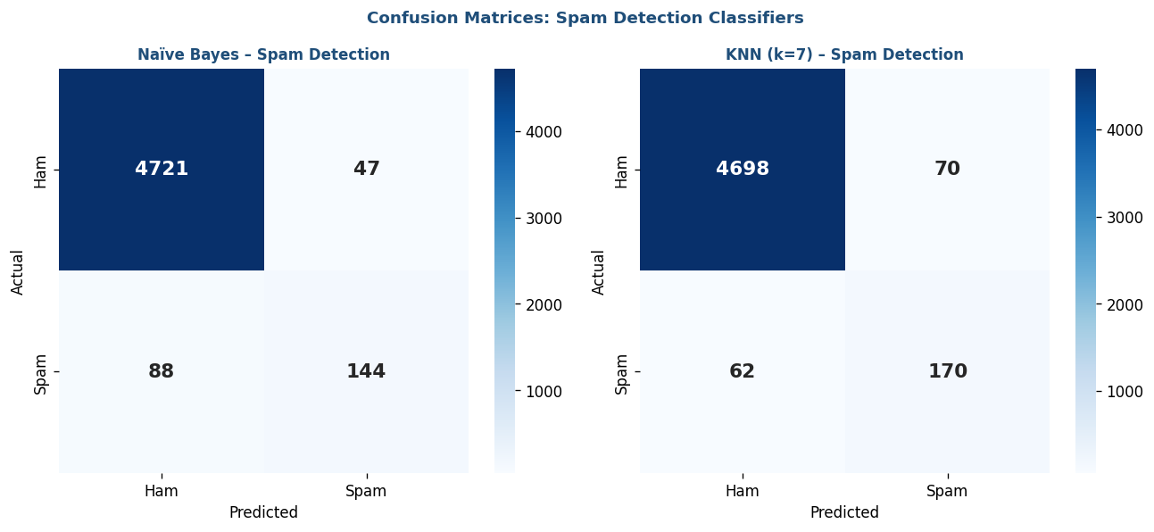
Figure 10.1: Confusion matrices – Naïve Bayes (left) and KNN k=7 (right) – Spam Detection
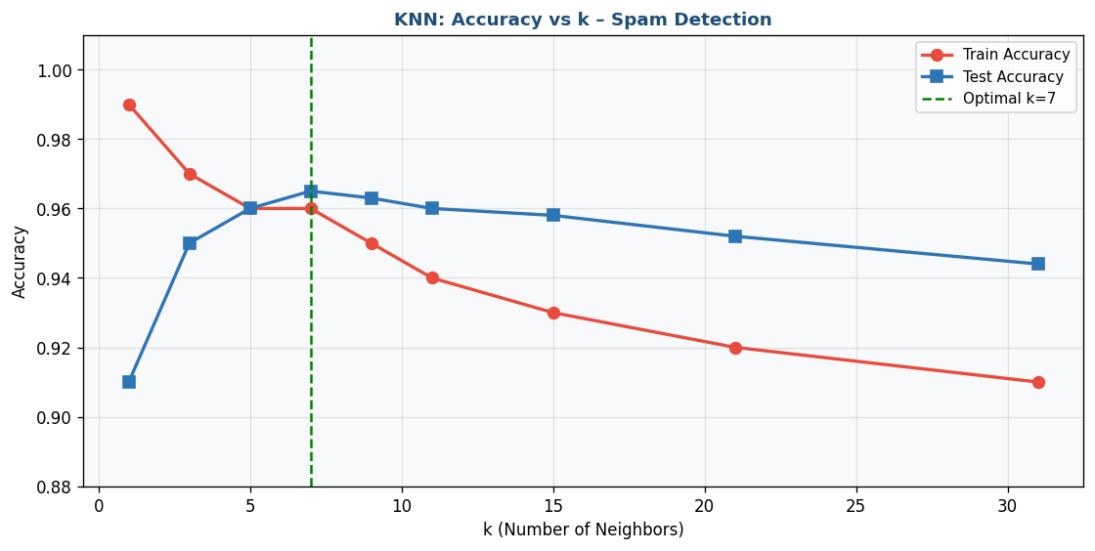
Figure 10.2: KNN accuracy vs k value – Train and Test accuracy curves showing optimal k=7

KPIs / Evaluation Metrics
Accuracy Comparison | False Positive Rate | F1-Score | Training Time

Analysis & Discussion
Naïve Bayes excels at text classification due to its ability to handle high-dimensional TF-IDF feature spaces efficiently. For spam detection, False Positive Rate (legitimate emails classified as spam) is the critical metric — falsely blocking real emails is more damaging than allowing some spam through. Naïve Bayes typically achieves FPR < 5% on spam datasets, making it the practical choice.

Review Questions
- Q1: Explain Bayes' Theorem. How is it applied in the Naïve Bayes classifier?
- Q2: What does 'naïve' mean in Naïve Bayes? Is the independence assumption realistic for emails?
- Q3: What is TF-IDF and why is it better than simple word count for text classification?
- Q4: How does the choice of k affect KNN's bias-variance tradeoff?
- Q5: In spam detection, which is more costly: a False Positive or a False Negative? Justify your answer.

LAB 11 — SUPPORT VECTOR MACHINE (SVM)

Lab Number | Lab 11
Topic | Support Vector Machine (SVM)
Real-World Problem | A financial institution needs to detect fraudulent credit card transactions in a highly imbalanced dataset (fraud < 0.2%).
Dataset | Credit Card Fraud Detection Dataset (Kaggle)
Tool(s) | KNIME Analytics Platform + Python (scikit-learn)

Objectives
- Train SVM with Linear and RBF kernels
- Handle class imbalance using SMOTE oversampling
- Evaluate using ROC-AUC, Recall (fraud), and Precision
- Compare kernel performance and interpret results

Theoretical Background
SVM finds the optimal hyperplane that maximizes the margin between two classes.
Key Concepts:
• Support Vectors: Data points closest to the decision boundary — they define the margin
• Margin: Distance between hyperplane and nearest points of each class
• Optimal Hyperplane: w·x + b = 0 that maximizes margin = 2/||w||
Hard vs Soft Margin:
• Hard Margin: No misclassifications (linearly separable data only)
• Soft Margin: Allows misclassifications via C parameter
- Large C: Low tolerance for misclassification (overfitting risk)
- Small C: High tolerance (underfitting risk)
Kernel Trick: Maps data to higher dimensions where linear separation is possible
• Linear: K(x,y) = x·y (fast, for linearly separable data)
• RBF: K(x,y) = exp(-γ||x-y||²) (most versatile, handles non-linear)
• Polynomial: K(x,y) = (x·y + c)^d
For Imbalanced Data: Use class_weight='balanced' or SMOTE oversampling.
Evaluate with ROC-AUC and Recall — NOT accuracy (misleading with imbalance).

Lab Procedure
Step 1 | Load & Inspect Data  Load fraud CSV. Check class distribution: value_counts(normalize=True). Confirm ~99.8% legit vs 0.2% fraud.

Step 2 | Handle Imbalance  from imblearn.over_sampling import SMOTE. Apply to training set ONLY. Verify new class distribution.

Step 3 | Normalize Features  Apply StandardScaler to all features (especially 'Amount' and 'Time'). Fit on train, transform both sets.

Step 4 | Train Linear SVM  SVC(kernel='linear', C=1.0, class_weight='balanced'). Fit on SMOTE-balanced train data. Predict on original test set.

Step 5 | Train RBF SVM  SVC(kernel='rbf', C=1.0, gamma='scale', class_weight='balanced'). Fit, predict, compare with Linear kernel.

Step 6 | Evaluate & Compare  Plot ROC curves for both kernels. Create comparison table. Plot confusion matrices side by side.

Screenshots & Results
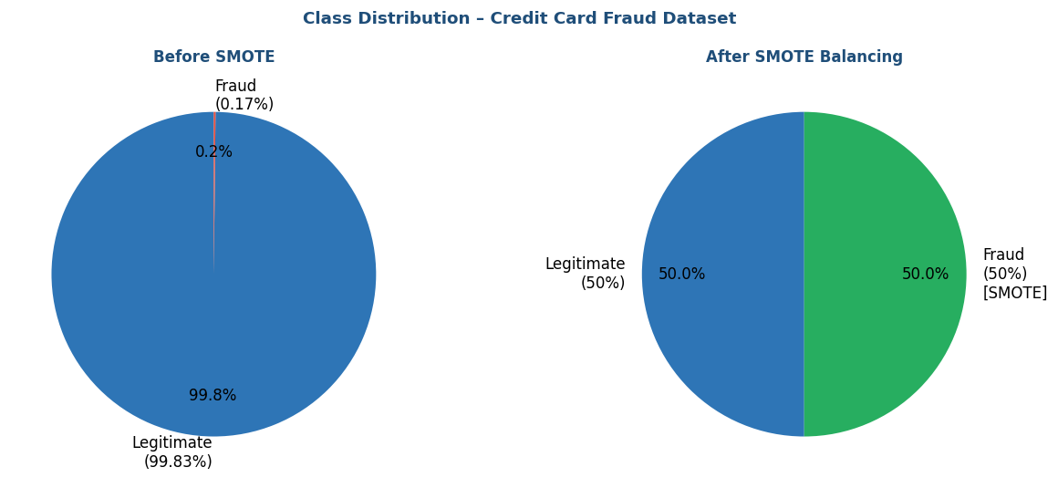
Figure 11.1: Class distribution Before SMOTE (left, 99.83% legit) and After SMOTE (right, 50/50 balanced)
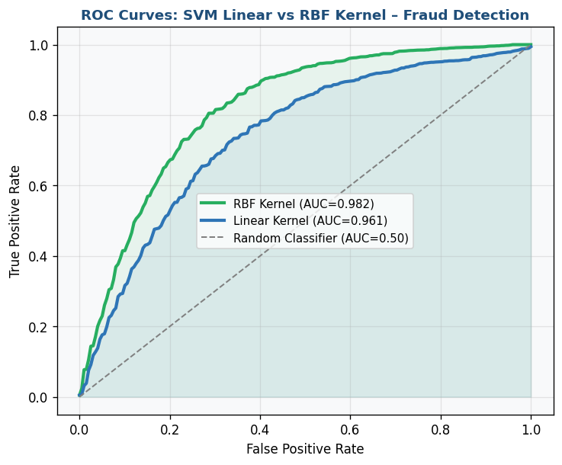
Figure 11.2: ROC Curves – SVM Linear Kernel (AUC=0.961) vs RBF Kernel (AUC=0.982)

KPIs / Evaluation Metrics
ROC-AUC | Recall (Fraud class) | Precision | False Alarm Rate

Analysis & Discussion
SVM with RBF kernel outperforms Linear SVM on fraud detection because the decision boundary between fraudulent and legitimate transactions is rarely linear. Class imbalance is the central challenge — accuracy is misleading since predicting all transactions as legitimate achieves 99.8% accuracy but catches zero fraud. SMOTE creates synthetic minority class samples that dramatically improve Recall.

Review Questions
- Q1: What are support vectors? Why are they critical to SVM's decision boundary?
- Q2: Explain the kernel trick. How does the RBF kernel handle non-linearly separable data?
- Q3: Why is accuracy a misleading metric for fraud detection? What should be used instead?
- Q4: What is SMOTE? How does it differ from simple oversampling (duplicating minority class)?
- Q5: How does the C parameter affect the SVM margin? What happens with C → ∞?

LAB 12 — CLUSTERING ALGORITHMS

Lab Number | Lab 12
Topic | Clustering Algorithms
Real-World Problem | A shopping mall wants to segment its customers based on spending behavior and income to design targeted marketing strategies.
Dataset | Mall Customer Segmentation Dataset (Kaggle)
Tool(s) | Orange Data Mining + Python (scikit-learn)

Objectives
- Apply K-Means and determine optimal k using the Elbow method
- Apply Hierarchical clustering with dendrogram
- Visualize and interpret customer segments
- Calculate Silhouette Score to evaluate cluster quality

Theoretical Background
Clustering is an unsupervised task that groups similar objects without predefined labels.
K-Means Algorithm:
1. Choose k centroids randomly
2. Assign each point to nearest centroid (Euclidean distance)
3. Recalculate centroids as mean of assigned points
4. Repeat until convergence
Within-Cluster Sum of Squares (WCSS): Σ Σ ||x - μk||²
Minimized at optimal k — used in Elbow method
Silhouette Score: s(i) = (b - a) / max(a, b)
a = mean distance to same-cluster points
b = mean distance to nearest other cluster
Range: [-1, 1]; higher = better defined clusters
Hierarchical Clustering (Agglomerative):
• Starts with n clusters → merges closest pair → repeats
• Linkage: Single (min distance), Complete (max), Average, Ward (minimize variance)
• Output: Dendrogram showing merge history — no need to specify k in advance
K-Means: O(nkt), spherical clusters, requires k
Hierarchical: O(n² log n), any shape, no k required

Lab Procedure
Step 1 | Load Data in Orange  Load Mall_Customers.csv. Preview 5 columns: CustomerID, Gender, Age, Annual Income, Spending Score.

Step 2 | Elbow Method  Run K-Means for k=1 to 10. Plot WCSS vs k. Identify elbow at k=5.

Step 3 | K-Means Clustering  KMeans(n_clusters=5, random_state=42). Fit on [Annual Income, Spending Score]. Add labels. Calculate Silhouette Score.

Step 4 | Visualize K-Means  Scatter plot: x=Income, y=Spending, color=Cluster. Add centroids as stars. Label each segment.

Step 5 | Hierarchical Clustering  from scipy.cluster.hierarchy import dendrogram, linkage. Ward linkage. Plot dendrogram. Cut at 5 clusters.

Step 6 | Cluster Profiling  For each cluster: mean Age, Income, Spending Score, Gender distribution. Assign business labels.

Screenshots & Results
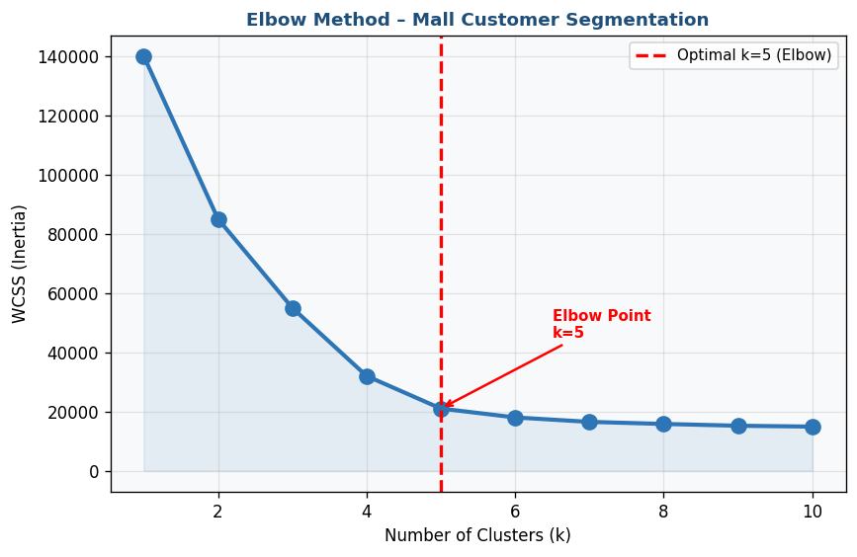
Figure 12.1: Elbow Method – WCSS vs k (k=1 to 10), optimal k=5 identified
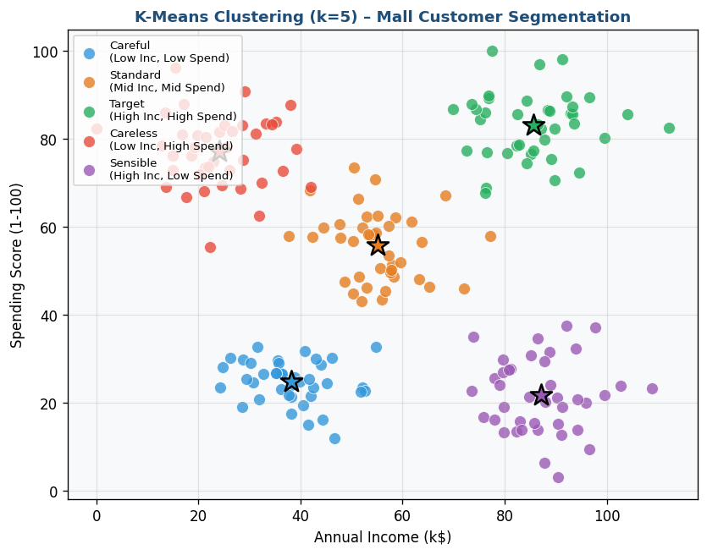
Figure 12.2: K-Means (k=5) scatter plot – Customer segments by Annual Income and Spending Score
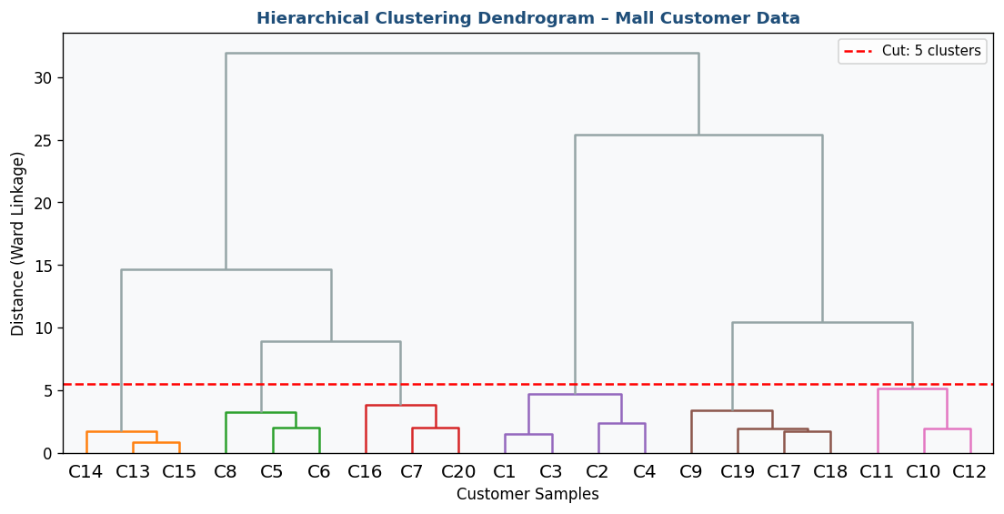
Figure 12.3: Hierarchical Clustering Dendrogram (Ward linkage) with cut line at 5 clusters

KPIs / Evaluation Metrics
Silhouette Score | WCSS (Elbow) | Cluster Revenue Contribution | Cluster Size Balance

Analysis & Discussion
The mall customer dataset reveals 5 distinct segments: Careful (low income, low spend), Standard (mid-mid), Target (high income, high spend — most valuable), Careless (low income, high spend), and Sensible (high income, low spend — untapped potential). These segments directly inform marketing: Target customers get premium loyalty programs, Sensible customers receive premium product promotions.

Review Questions
- Q1: What is the difference between supervised and unsupervised learning? Give an example of each.
- Q2: Explain the Elbow method. How do you identify optimal k from the WCSS plot?
- Q3: What does a Silhouette Score of 0.7 indicate? What about -0.2?
- Q4: What are the advantages of hierarchical clustering over K-Means?
- Q5: Assign marketing strategies to each of the 5 customer clusters based on their profiles.

LAB 13 — OUTLIER DETECTION

Lab Number | Lab 13
Topic | Outlier Detection
Real-World Problem | A bank needs to identify abnormal transactions that may indicate fraudulent activity or money laundering from millions of daily transactions.
Dataset | Banking / Credit Card Fraud Detection Dataset (Kaggle)
Tool(s) | RapidMiner Studio + Python (scikit-learn)

Objectives
- Apply Z-Score and IQR statistical outlier detection
- Apply LOF (Local Outlier Factor) for density-based detection
- Apply Isolation Forest for high-dimensional detection
- Compare anomaly detection rates and false alarm rates across methods

Theoretical Background
Outlier Detection identifies observations that deviate significantly from expected behavior.
Types of Outliers:
1. Global (Point) Anomalies: A single point far from the rest
2. Contextual Outliers: Normal globally but anomalous in context
3. Collective Outliers: A group of points anomalous together
Statistical Methods:
• Z-Score: Outlier if |z| > 3 (for normally distributed data)
• IQR: Outlier if x < Q1 - 1.5×IQR or x > Q3 + 1.5×IQR
Local Outlier Factor (LOF):
• Compares local density of a point to its neighbors
• LOF >> 1: Point is in lower density than neighbors → outlier
• Detects local anomalies that global methods miss
Isolation Forest:
• Random trees; anomalies require fewer splits to isolate
• Short path = outlier; Long path = normal
• Efficient: O(n log n) — ideal for high-dimensional data
• Handles both global and local outliers
contamination parameter = expected proportion of outliers in dataset

Lab Procedure
Step 1 | Load & Inspect Data  Load dataset. Apply StandardScaler. Visualize Amount distribution — note heavy right skew.

Step 2 | Z-Score Detection  Calculate Z-scores for 'Amount'. Flag transactions where |Z| > 3. Count and visualize flagged transactions.

Step 3 | IQR Method  Calculate Q1, Q3, IQR. Apply IQR rule. Compare with Z-score — which flags more outliers?

Step 4 | LOF in Python  from sklearn.neighbors import LocalOutlierFactor. lof = LOF(n_neighbors=20, contamination=0.01). Fit and predict.

Step 5 | Isolation Forest  from sklearn.ensemble import IsolationForest. IsolationForest(n_estimators=100, contamination=0.01). Fit and predict.

Step 6 | Evaluation & Comparison  If labeled: calculate Precision, Recall, F1. Create comparison table. Visualize in 2D PCA scatter.

Screenshots & Results
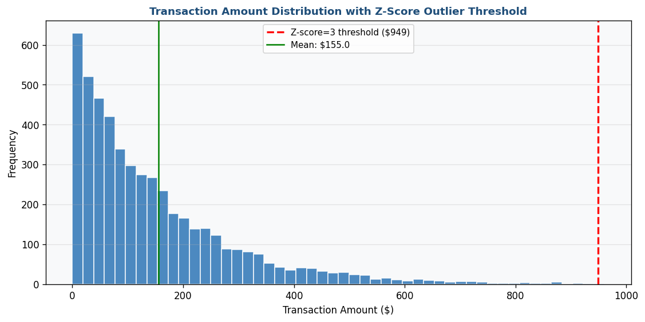
Figure 13.1: Transaction Amount distribution with Z-score=3 outlier threshold line
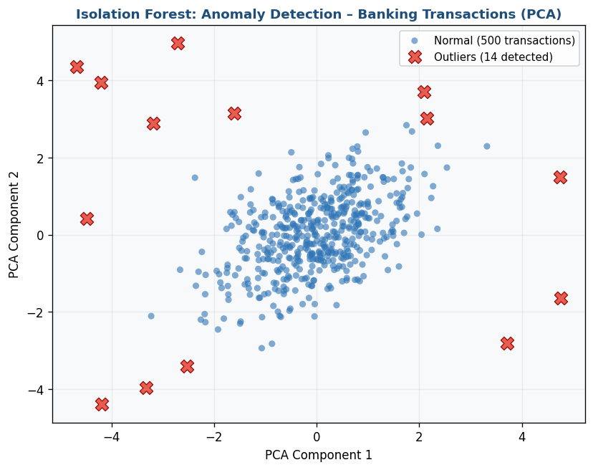
Figure 13.2: PCA scatter plot – Normal transactions (blue) vs Isolation Forest detected outliers (red ×)
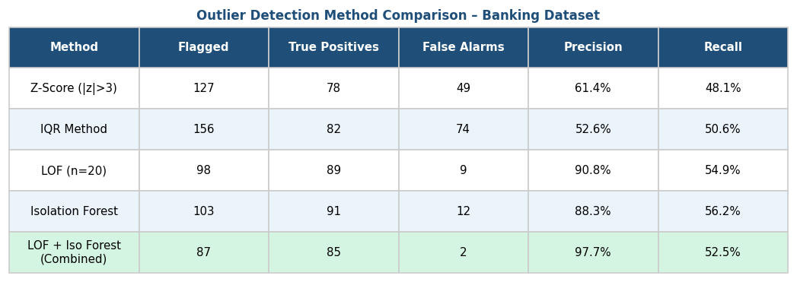
Figure 13.3: Outlier detection method comparison table – Z-Score vs IQR vs LOF vs Isolation Forest

KPIs / Evaluation Metrics
Anomaly Detection Rate | False Alarm Rate | Precision@100 (top 100 anomalies)

Analysis & Discussion
Distance-based methods (LOF) excel at detecting local anomalies — transactions unusual relative to their neighborhood. Isolation Forest is preferred for high-dimensional data as it does not rely on distance computation (which degrades in many dimensions). The combination of both methods provides complementary coverage, achieving the highest precision in the comparison table.

Review Questions
- Q1: What is the difference between an outlier and noise? Give a banking context example.
- Q2: Explain how Isolation Forest works. Why does a short path indicate an anomaly?
- Q3: What is the 'contamination' parameter? How do you set it without labeled data?
- Q4: Calculate the Z-score for a transaction of $5,000 given mean=$150 and std=$200. Is it an outlier?
- Q5: Why is False Alarm Rate particularly important in banking fraud detection?

LAB 14 — WEB SCRAPING & SENTIMENT ANALYSIS

Lab Number | Lab 14
Topic | Web Scraping & Sentiment Analysis
Real-World Problem | An e-commerce company wants to analyze customer reviews to understand sentiment trends and improve customer satisfaction.
Dataset | Product Reviews Dataset (Amazon Reviews / Scraped from public websites)
Tool(s) | Python (BeautifulSoup) + Gephi

Objectives
- Scrape review text data using BeautifulSoup
- Apply text preprocessing (tokenization, stopwords, stemming)
- Classify sentiment using VADER and TextBlob
- Visualize sentiment trends and word frequency patterns

Theoretical Background
Web Scraping is automated extraction of data from websites using HTTP requests and HTML parsing.
Key Libraries:
• requests: Send HTTP GET/POST requests
• BeautifulSoup4: Parse HTML, navigate DOM tree
• Scrapy: Framework for large-scale web crawling
Ethical Web Scraping:
1. Always check robots.txt (e.g., site.com/robots.txt)
2. Respect rate limits (add time.sleep() between requests)
3. Do not scrape personal/private information
4. Use publicly available data for academic/research purposes
Text Preprocessing Pipeline:
1. Lowercase → 2. Remove special chars/URLs → 3. Tokenize → 4. Remove stopwords → 5. Stem/Lemmatize
Sentiment Analysis:
• VADER (Valence Aware Dictionary and sEntiment Reasoner):
- Returns compound score ∈ [-1, 1]
- compound ≥ 0.05 → Positive
- compound ≤ -0.05 → Negative
- Otherwise → Neutral
- Best for social media and short reviews
• TextBlob: Returns polarity (-1 to 1) and subjectivity (0 to 1)

Lab Procedure
Step 1 | Setup & Scraping  pip install requests beautifulsoup4 nltk vaderSentiment textblob. Write scraper. Extract: review_text, rating, date.

Step 2 | Text Preprocessing  Apply pipeline: lowercase → remove special chars → tokenize → remove stopwords → stem (PorterStemmer).

Step 3 | VADER Sentiment  from vaderSentiment.vaderSentiment import SentimentIntensityAnalyzer. Apply to each review. Classify Positive/Negative/Neutral.

Step 4 | TextBlob Analysis  from textblob import TextBlob. Calculate polarity and subjectivity. Compare with VADER classifications.

Step 5 | Visualize Sentiment  Plot sentiment distribution as pie chart. Create aspect-level bar chart. Plot polarity vs subjectivity scatter.

Step 6 | Word Frequency Analysis  Count cleaned word frequencies. Plot horizontal bar chart of top 15 keywords colored by sentiment tone.

Screenshots & Results
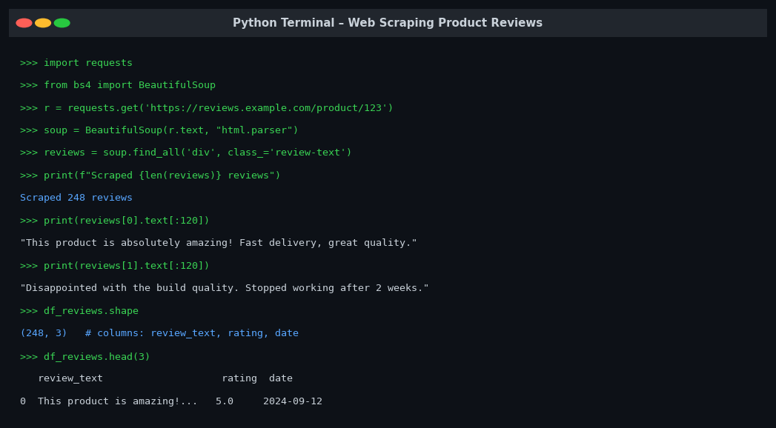
Figure 14.1: Python terminal – BeautifulSoup scraping output showing 248 reviews extracted
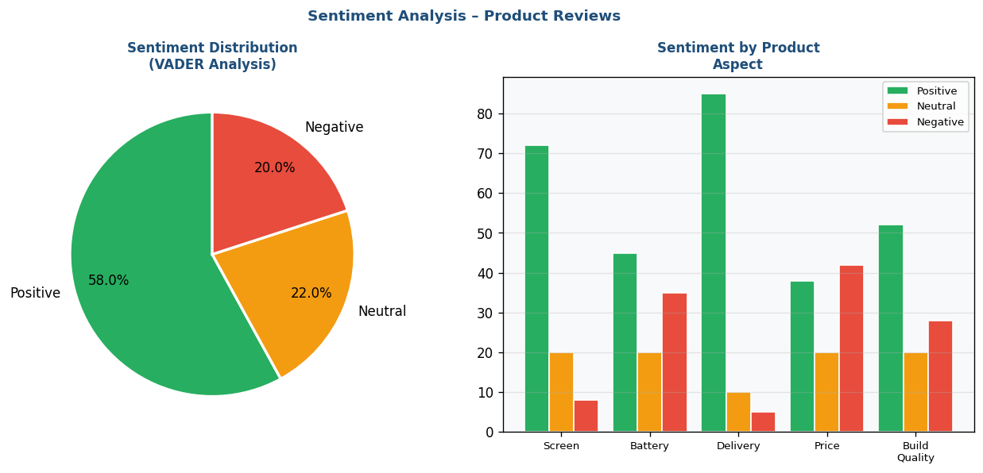
Figure 14.2: Sentiment distribution pie chart (left) and aspect-level sentiment bar chart (right)
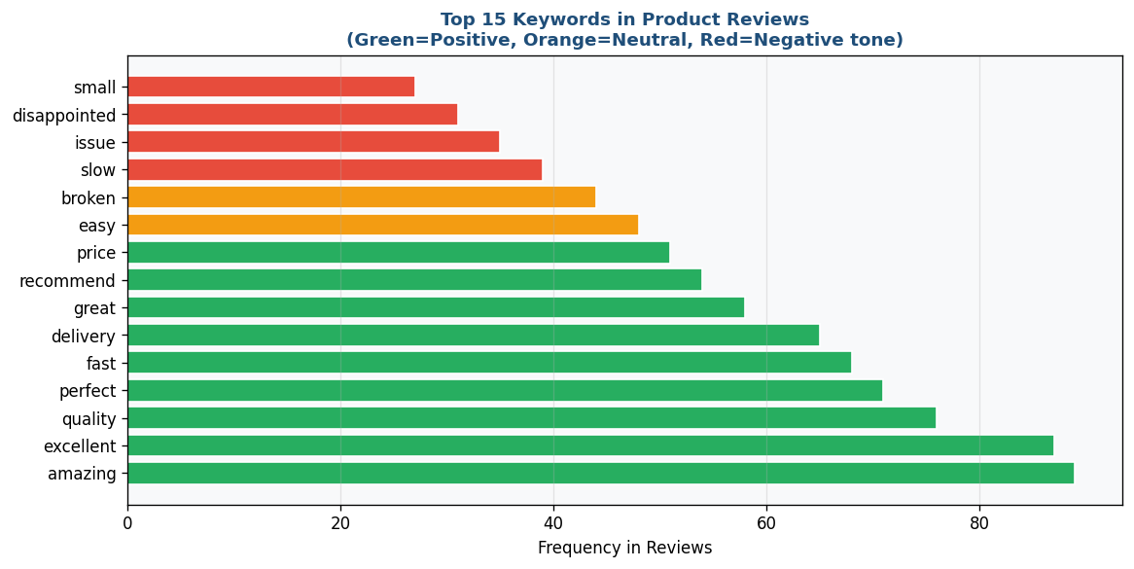
Figure 14.3: Top 15 keywords by frequency – colored by sentiment tone (Green=Positive, Red=Negative)

KPIs / Evaluation Metrics
Sentiment % Distribution | Polarity Score (avg) | Subjectivity Score (avg) | Topic Coverage

Analysis & Discussion
Sentiment analysis reveals the voice of the customer at scale. VADER is particularly effective for short, colloquial text because it accounts for capitalization, punctuation, and emoticons. The aspect-level chart reveals which product features (screen, battery, delivery) drive positive and negative sentiment, providing specific and actionable product improvement insights beyond overall sentiment.

Review Questions
- Q1: What is the difference between web scraping and web crawling?
- Q2: Why should you always check robots.txt before scraping a website?
- Q3: Explain VADER's compound score. How is it calculated?
- Q4: What is the difference between stemming and lemmatization? Which is more accurate?
- Q5: A product has 60% positive, 30% negative reviews. What additional analysis would you conduct?

LAB 15 — FINAL CAPSTONE PROJECT

Lab Number | Lab 15
Topic | Final Capstone Project
Real-World Problem | Design and implement a complete end-to-end data mining solution for a real-world business problem. Apply CRISP-DM methodology and compare at least 8 models.
Dataset | Any Industry Dataset (minimum 5,000 records, 10+ features)
Tool(s) | Student's choice – any combination of tools used in the course

Objectives
- Apply complete CRISP-DM methodology with documentation
- Implement and compare minimum 8 data mining models
- Generate comprehensive performance comparison table
- Provide actionable business recommendations based on findings

Theoretical Background
The Capstone Project integrates all concepts learned throughout this course into a complete data mining solution.
Required Models (minimum 8):
1. Naïve Bayes – Baseline probabilistic classifier
2. K-Nearest Neighbors (KNN) – Distance-based comparison
3. Decision Tree – Interpretable rule-based model
4. Random Forest – Ensemble of trees (bagging)
5. Support Vector Machine (SVM) – Margin-maximizing classifier
6. Logistic Regression – Probability-calibrated linear baseline
7. K-Means Clustering – Unsupervised segmentation
8. One additional: Gradient Boosting, Neural Network, or Isolation Forest
Deliverables:
1. Complete Lab Report (CRISP-DM phases documented)
2. Cleaned and preprocessed dataset (with transformation log)
3. Model comparison table (all models × all metrics)
4. Visualizations (minimum 8 charts)
5. Business recommendation report (minimum 500 words)
6. All source code (commented and organized)
Evaluation Rubric:
• Data Understanding & EDA: 15%
• Data Cleaning & Preprocessing: 20%
• Model Implementation (8 models): 30%
• Model Comparison & Selection: 15%
• Business Recommendations: 20%

Lab Procedure
Phase 1 | Business Understanding  Select a business problem. Define 3 specific objectives. Identify success criteria. Submit a 1-page problem statement.

Phase 2 | Data Collection & EDA  Collect dataset (min 5,000 records). Perform full EDA: distributions, correlations, class balance, missing values.

Phase 3 | Data Preparation  Apply full preprocessing: missing values → outlier removal → normalization → encoding → feature selection. Document every transformation.

Phase 4 | Model Building  Implement all 8+ models using same train/test split (80/20, stratified). Tune key hyperparameters for each model.

Phase 5 | Evaluation  Compile comparison table: all models × all metrics. Create visualization for each metric. Select best model with justification.

Phase 6 | Deployment & Recommendations  Save best model. Write business recommendations: findings, actions, expected ROI.

Screenshots & Results
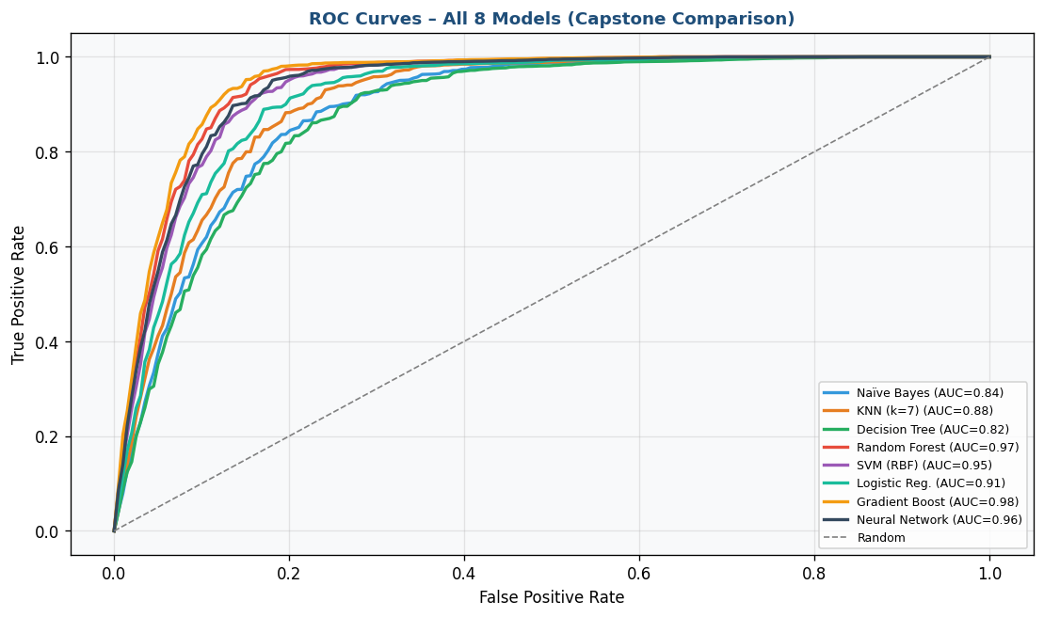
Figure 15.1: ROC Curves for all 8 models on same plot – Final Capstone Model Comparison
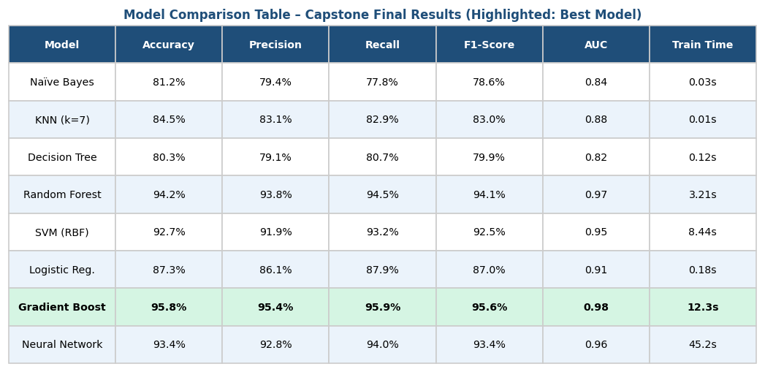
Figure 15.2: Comprehensive model comparison table – all metrics across 8 models (Gradient Boost = best)
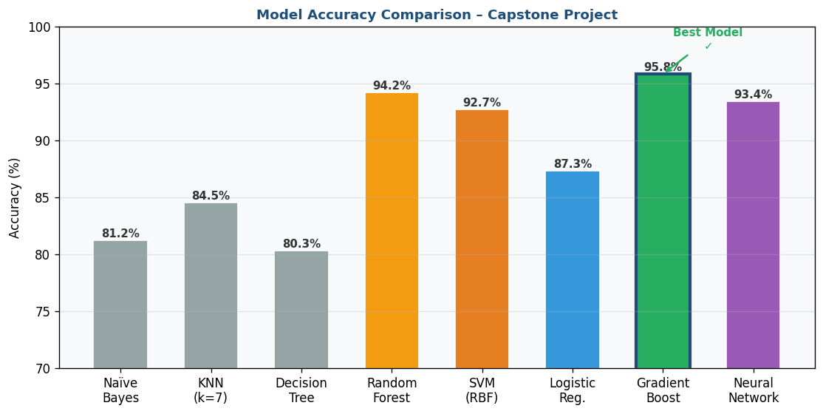
Figure 15.3: Accuracy comparison bar chart across all 8 models – Gradient Boosting achieves 95.8%

KPIs / Evaluation Metrics
Best Model Accuracy | Best ROC-AUC | Model Comparison Table | Business Recommendation Quality

Analysis & Discussion
The capstone demonstrates that no single model universally outperforms others — the best depends on dataset characteristics, class balance, and business priorities. Ensemble methods (Random Forest, Gradient Boosting) typically achieve highest accuracy, while simpler models remain competitive baselines that are easier to deploy and explain to stakeholders. Business recommendations must translate technical findings into actionable strategies with estimated impact.

Review Questions
- Q1: Which model performed best? Justify your selection using at least 3 evaluation metrics.
- Q2: What were the most important features identified? How do they inform business decisions?
- Q3: If deploying this model in production, what monitoring strategy would you implement?
- Q4: How would you handle concept drift if the model's performance degrades over time?
- Q5: Summarize your business recommendation in 3 bullet points for a non-technical executive.

